A000-US-OH-Scioto Co-Platform Pipe-Squirrel Effigy-Sterling Pipestone-Hopewell-100 BCE-500

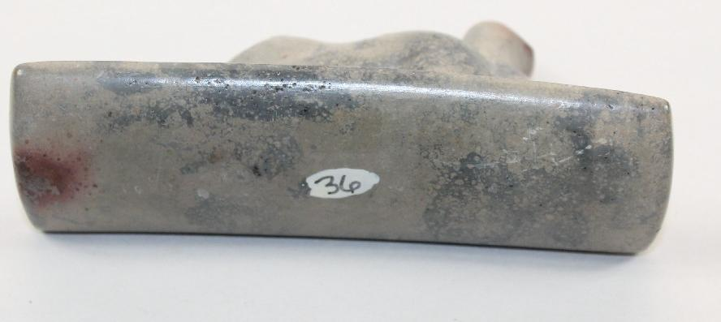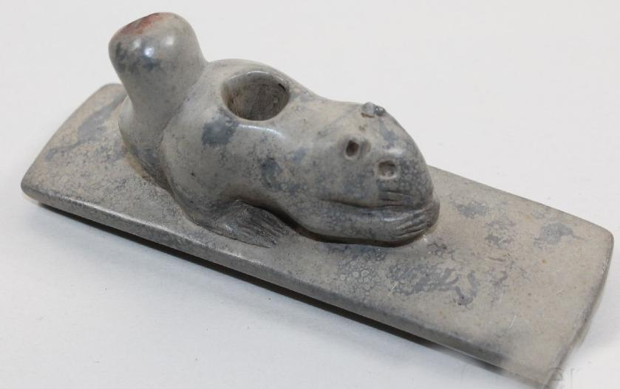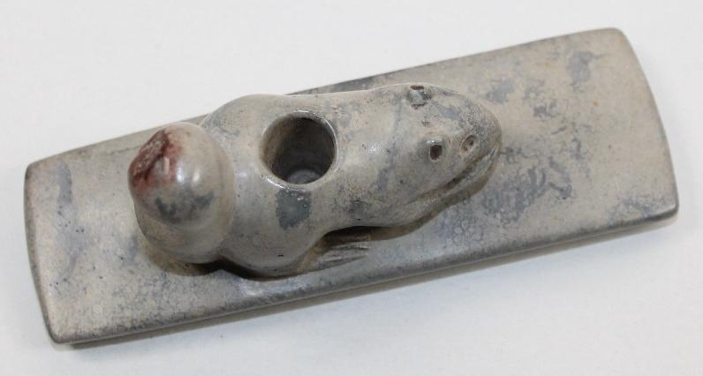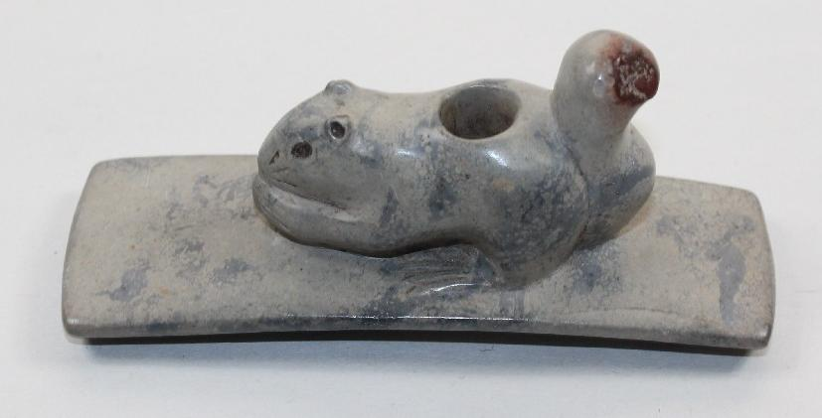

**Case no.: 11**

**Accession Number:**

**Formal Label:** US-OH-Scioto Co-Platform Pipe-Squirrel Effigy-Sterling Pipestone-Hopewell-100 BCE-500

**Display Description:**

Pipestone in the Upper Midwest is frequently associated with the “calumet ceremony” (Blakeslee 1981; Brown 1989). This ceremony contains “an adoption ritual . . . which establish[es] a fictive kinship relationship between individuals of different clans, bands, or ethnic groups” (Blakeslee 1981:759), thus making “friends out of foes” (Brown 1989:313) which is appropriate for the find spots of these effigies which are associated with seasonal Rendezvous in which goods or nubile youth are exchanged. In some First Nations societies, the smoking of the pipestone pipe, usually in its red color variants which has the force of blood–red or re-vitalization, which sanctions a person to be reborn into new life circumstances (Brown 2007:95–96). The “calumet ceremony” likely began on the Great Plains and spread east onto the Prairie Peninsula and the Eastern Woodlands (Blakeslee 1981). In the present case the greyish pipestone was selected to approximate the color of the Squirrel Effigy that had , probably, a specific metaphoric meaning which we shall presently explore. To acquire this color of pipestone it was necessary to search out an unexpected quarry in Sterling, Illinois.

This Squirrel Effigy Platform Pipe incorporates two elements into its structure. The first element is a now lost pipe stem mouthpiece, which having been made of wood or reed disintegrated in its burial soil. This mouthpiece is termed a “calumet,” which is derived from the Norman word “chalumeau,” meaning“reed” which was coined by the first French missionaries of the latter 17h c. Pipe stems are considered more spiritually powerful than stone or ceramic pipe bowls. A “calumet” represents the energetic male principle.

The second element is the carved pipestone bowl that metaphorically represents powers associated with the female principle of socially and sexually conjoining. In the present artifact it is an effigy of a squirrel, which is meant not to refer to this particular fauna but to its Hopewellian metaphor. Together, the stem and the bowl represent the principle of harmony, and they are to be joined only during a ritual smoking of tobacco when concluding a ritual association among participants.

This squirrel is depicted with its hind legs on the platform of the pipe with its head bent forward and with its forelegs extended. It is grasping an object such as a metaphoric acorn or hickory nut. The paws have received special attention by the sculptor: all four feet are engraved with parallel oblique incised lines. Apparently, the ability of the squirrel to travel and to acquire goods are intended metaphorically. In addition, the squirrel was sexually active in the spring when many First Nations rendezvous were held such as the ones at Tremper Mound as surrounding areas when young people were given in marriage.

Therefore, the squirrel may be an encompassing emblem of this trans-regional, ritual network. The squirrel’s sturdy hind legs suggest the physical ability to reach a destination and the aggressive fore paws suggest the ability to procure needed goods. The expertly incised eyes and pointed ears (the latter which project above the head) suggest alertness. Its season of reproduction was the spring.

Thus, the squirrel’s complex metaphoric meanings combine four dimensions of Hopewellian life: 1) the ability of people to physically be able to journey to the Ohio mounds, 2) to transport needed goods probably by dog-powered travois for trade (including pipestone blanks for being carved into pipes), 3) to be alert to danger on the way, and 4) to accomplish the journey during the mating season for their youth as exogamous marriage was known as a method to avoid various incestuous birth defects.

**LC Classification:**

**Date or Time Horizon:** Hopewell Culture (100 BCE-500 CE)

**Geographical Area:**

**Map:**

**GPS coordinates:**

**Cultural Affiliation:** Hopewell Culture (100 BCE-500 CE)

**Medium:** Sterling, IL, pipestone

**Dimensions:** 4" long by 1-1/2" tall by 1-3/8" wide

**Weight:**

**Condition: original**

**Provenance: from**  a native of Scioto Co., Ohio, c 1915, when the Tremper Mound was first excavated by William Mills. Gary Litherland procured it from someone working with Mills. This piece was finally in the Bob Olson Collection for about 25 years, when I procured it from Bob.

**Discussion:**

In Ohio, the Hopewell People (100 BCE-500 CE) built large earthen enclosures in geometric shapes (circles, squares, and octagons) to mark places where diverse First Nations Peoples gathered periodically to participate in many social and ceremonial events. Some of these sites were quite large, such as the Newark Earthworks complex that extends over 4-mi2 and could contain groups numbered in the hundreds. These groups gathered seasonally, as the result of a inter-regional Hopewellian trade network that has been hypothesized to have extended as far east as the Appalachian Mountains, as far north as Lake Superior, as far west as the Rocky Mountains of Wyoming, and as far south as the coast of Florida. One aspect of this trade network is revealed in the raw material for the stone in the pipe. Recent research on the mineralogy of pipestone ha revealed a greatly expanded database of pipestone sources besides the Catlinite quarries of southwestern Minnesota and the Sterling quarries of Illinois. (See Appendix at end.)

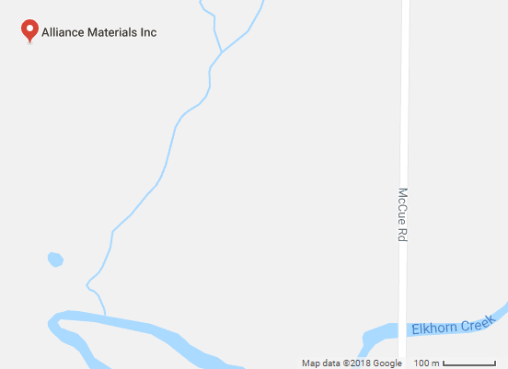 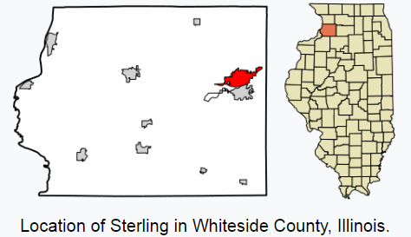

Left: location of Alliance Materials Inc., 5506 Emerson Rd; Sterling, Illinois 61081 adjacent to the prehistoric quarries in the area. [41°47′48″N 89°41′36″W](https://tools.wmflabs.org/geohack/geohack.php?pagename=Sterling,_Illinois&params=41_47_48_N_89_41_36_W_type:city(15370)_region:US-IL). Right: Location of Sterling in Whiteside Co., IL

This pipe is made of Sterling pipestone from northwestern Illinois and not from quarries along the Scioto River as previously thought. Since pipestone is a silica-based material that can be easily carved only when freshly quarried, this suggests that there was a regular supply chain of procurement of Sterling pipestone from northwestern Illinois to the Tremper Mound area that could transport quarried Sterling, IL, pipestone efficiently while it was the main source of more than 500 deliberately fragmented pipestone artifacts that had been deposited on one of the Tremper Mound’s eastern side chambers when an area was vacated or if the artifact required destruction to remove the inhering spirit. Included in this deposit were 136 smoking pipes of which 90 had sculpted effigies of birds (hawks, owls, herons, and cranes) or mammals (squirrels, bears, wolves, dogs, beavers, cougars, and otters). Many of these effigies probably had metaphoric meanings.

Hughes, R. E., T. E. Berres, D. M. Moore, and K. B. Farnsworth. 1998. [*Revision of Hopewellian trading patterns in midwestern North American based on mineralogical testing*](http://www3.interscience.wiley.com/cgi-bin/issuetoc?ID=77755)*.* Geoarchaeology 13(7):709-729.

Red Pipestone Artifacts from Oneota Villages

**References:**

1. Byers, A. Martin. *The Ohio Hopewell Episode: Paradigm Lost and Paradigm Gained*. Akron, OH: University of Akron Press, 2004.
2. Carr, Christopher, and D. Troy Case, eds. *Gathering Hopewell: Society, Ritual, and Ritual Interaction*. New York, NY: Kluwer Academic/Plenum Publishers, 2005.
3. Charles, Douglas K. and Jane E. Buikstra, editors, *Recreating Hopewell*.  Gainesville, University Press of Florida, 2006.
4. Dancey, William S., and Paul J. Pacheco. *Ohio Hopewell Community Organization*. Kent State University Press, 1997.
5. Lepper, Bradley T. *Ohio Archaeology: An Illustrated Chronicle of Ohio's Ancient American Indian Cultures.* Wilmington, Ohio, Orange Frazer Press, 2005.
6. Pangea Productions. *Searching for the Great Hopewell Road*. N.p.: Pangea Productions, 1998.
7. Warriner, Gray, producer. *Legacy of the Mound Builders*. Seattle, WA: Camera One for the National Park Service and the Hopewell Culture National Historical Park, 1994
8. Woodward, Susan L., and Jerry N. McDonald. *Indian Mounds of the Middle Ohio Valley: A Guide to Mounds and Earthworks of the Adena, Hopewell, Cole, and Fort Ancient People*. Lincoln: The University of Nebraska Press, 2002.

Alex, L. M. 2000 Iowa’s Archaeological Past. University of Iowa, Iowa City.

Anderson, D. C. 1994 Stone, Glass, and Metal Artifacts from the Milford Site (13DK1): An Early 18th Century Oneota Component in Northwest Iowa. Research Papers Vol. 19, No. 5. Office of the State Archaeologist, University of Iowa, Iowa City.

Baerreis, D. A. 1968 Artifact Descriptions: Bone, Stone, and Shell. Journal of the Iowa Archeological Society 15:107–191.

Billeck, W. T. 1993 Time and Space in the Glenwood Locality: The Nebraska Phase in Western Iowa. Unpublished PhD. dissertation, Department of Anthropology, University of Missouri, Columbia.

Blakeslee, D. J. 1981 The Origin and Spread of the Calumet Ceremony. American Antiquity 46:759–768.

Blakeslee, D. J., and W. W. Caldwell 1979 The Nebraska Phase: An Appraisal. Reprints in Anthropology No. 18. J & L Reprint Company, Lincoln, Nebraska.

Blakeslee, D. J., M. Peck, and R. A. Dorsey 2001 Glen Elder: A Western Oneota Bison Hunting Camp. Midcontinental Journal of Archaeology 26:79–104.

Boszhardt, R. F. 1994 Oneota Group Continuity at LaCrosse: The Brice Prairie, Pammel Creek, and Valley View Phases. The Wisconsin Archeologist 75:173–236.

Boszhardt, R. F. 1998 Oneota Horizons: A LaCrosse Perspective. The Wisconsin Archeologist 79(2):196–226.

Boszhardt, R. F., and J. N. Gundersen 2003 X-Ray Powder Diffraction Analysis of Early and Middle Woodland Red Pipes from Wisconsin. Midcontinental Journal of Archaeology 28:33–47.

Bray, R. T. 1963 Southern Cult Motifs from the Utz Oneota Site, Saline County, Missouri. The Missouri Archaeologist 25:1–40.

Brown, I. W. 1989 The Calumet Ceremony in the Southeast and Its Archaeological Manifestations. American Antiquity 54:311–331.

Brown, J. A. 2007 On the Identity of the Birdman within Mississippian Period Art and Iconography. In Ancient Objects and Sacred Realms: Interpretations of Mississippian Iconography, edited by F. K. Reilly III and J. F. Gerber, pp. 56–106. University of Texas, Austin.

Brown, J. A., and P. J. O’Brien (editors) 1990 At the Edge of Prehistory: Huber Phase Archaeology in the Chicago Area. Center for American Archeology, Kampsville, Illinois.

Catlin, G. 1973 [1844] Letters and Notes on the Manners, Customs, and Conditions of the North American Indians. 2 vols. Dover, New York.

Dobbs, C. A. 1984 Oneota Settlement Patterns in the Blue Earth River Valley, Minnesota. Unpublished PhD. dissertation, Department of Anthropology, University of Minnesota, Minneapolis.

Doershuk, J. F. 1997 Recent Excavations at the Gillett Grove Site, Clay County, Ia. Iowa Archeological Society Newsletter 47(3):1–3. 2002 Summer 2002 Excavations at 13CY2, the Gillett Grove Site. Iowa Archeological Society Newsletter 52(4):1–3.

Doershuk, J. F., and K. D. Resnick 2008 Oneota Technological Adaptations to European Fur Trade Goods in Northwest Iowa. Poster presented at the 54th Annual Midwest Archaeological Conference, Milwaukee, Wisconsin.

Emerson, T. E., and R. E. Hughes 2000 Figurines, Flint Clay Sourcing, the Ozark Highlands, and Cahokia Acquisition. American Antiquity 65:79-101.

Emerson, T. E., and R. E. Hughes. 2001 De-Mything the Cahokia Catlinite Trade. Plains Anthropologist 46:149–161.

Emerson, T. E., R. E. Hughes, K. B. Farnsworth, S. U. Wisseman, and M. R. Hynes 2005 Tremper Mound, Hopewell Catlinite, and Pima Technology. Midcontinental Journal of Archaeology 30:189–216.

Emerson, T. E., R. E. Hughes, M. R. Hynes, and S. U. Wisseman 2002 Implications of Sourcing Cahokia-Style Flint Clay Figures in the American Bottom and the Upper Mississippi River Valley. Midcontinental Journal of Archaeology 27:309–338.

Emerson, T. E., R. E. Hughes, M. R. Hynes, and S. U. Wisseman 2003 The Sourcing and Interpretation of Cahokia-Style Figurines in the TransMississippi South and Southeast. American Antiquity 68:287–313.

Esarey, D., and L. A. Conrad 1998 The Bold Counselor Phase of the Central Illinois River Valley: Oneota’s Middle Mississippian Margin. The Wisconsin Archeologist 79(2):38–61.

Esarey, D., and S. K. Santure 1990 The Morton Site Oneota Component and the Bold Counselor Phase. In Archaeological Investigations at the Morton Village and the Norris Farms 36 Cemetery, edited by S. K. Santure, A. D. Harn, and D. Esarey, pp. 162–166. Reports of Investigations No. 45. Illinois State Museum, Springfield.

Farnsworth, K. B., T. E. Berres, R. E. Hughes, and D. M. Moore 2004 Illinois Platform Pipes and Hopewellian Exchange: A Minerological Study of Archaeological Remains. In Aboriginal Ritual and Economy in the Eastern Woodlands: Essays in Memory of Howard Dalton Winters, edited by A. Cantwell, L. A. Conrad, and J. E. Reyman, pp. 182–213. Scientific Papers Vol. XXX. Illinois State Museum, Springfield.

Farnsworth, K. B., and J. O’Gorman 1998 Oneota in the Lower Illinois River Valley. The Wisconsin Archeologist 79(2):62–92. Finney, F. A., and G. T. Crawford

Farnsworth, K. B., and J. O’Gorman 1999 Chipped Stone Assemblage. In Bison Hunters of the Western Prairies: Archaeological Investigations at the Dixon Site (13WD8), Woodbury County, Iowa, edited by R. L. Fishel, pp. 51–59. Report 21. Office of the State Archaeologist, University of Iowa, Iowa City.

Fishel, R. L. (editor) 1999 Bison Hunters of the Western Prairies: Archaeological Investigations at the Dixon Site (13WD8), Woodbury County, Iowa. Report 21. Office of the State Archaeologist, University of Iowa, Iowa City.

Fishel, R. L. 1996 Dixon to Leary to White Rock: A Hypothesis for Oneota 14th Century Communal Bison Hunts. Paper presented at the 54th Annual Plains Anthropological Conference, Iowa City.

Fishel, R. L. 2001 Oneota Overview of South Central Iowa. Journal of the Iowa Archeological Society 48:59–69.

Fishel, R. L., and J. M. Titcomb 2009 Sourcing Red Pipestone Artifacts from Northwest Iowa. Iowa Archeological Society Newsletter 59(1):6–7.

Fishel, R.L., Wisseman, S.U., Hughes, R.E. and Emerson, T.E., 2010. Sourcing Red Pipestone Artifacts from Oneota Villages in the Little Sioux Valley of Northwest Iowa. *Midcontinental Journal of Archaeology*, *35*(2), pp.167-198.

Fugle, E. 1962 Mill Creek Culture and Technology. Journal of the Iowa Archeological Society 11(4):3–126.

Gibbon, G. E. 1983 The Blue Earth Phase of Southern Minnesota. Journal of the Iowa Archeological Society 30:1–84.

Gundersen, J. N. 1987 Wisconsin Pipestone: A Preliminary Mineralogical Examination. The Wisconsin Archeologist 68:1–21.

Gundersen, J. N. 1988 Pipestones of the St. Helena Phase. In St. Helena Archaeology: New Data, Fresh Interpretations, edited by D. J. Blakeslee, pp. 79–97. Reprints in Anthropology No. 39. J & L Reprint Company, Lincoln, Nebraska.

Gundersen, J. N. 1991 The Mineralogical Characterization of Catlinite from Its Sole Provenance, Pipestone National Monument, Minnesota. Research/Resources Management Report No. MWR-17. National Park Service, Omaha. Copies available from the National Park Service, Omaha, Nebraska.

Gundersen, J. N. 1993 “Catlinite” and the Spread of the Calumet Ceremony. American Antiquity 58:560–562.

Gundersen, J. N., and J. O’Shea 1981 The Mineralogy of Pipestone Artifacts and Raw Materials of the Barcal Site (Lower Loup Phase/Protohistoric Pawnee) of East Central Nebraska. Abstracts with Programs Vol. 13, No. 7, p. 465. Annual Meeting of the Geological Society of America, Cincinnati, Ohio.

Gundersen, J. N., and J. A. Tiffany 1986 Nature and Provenance of Red Pipestone from the Wittrock Site (13OB4), Northwest Iowa. North American Archaeologist 7:45–67.

Hamilton, H. W. 1967 Tobacco Pipes of the Missouri Indians. Memoir 5. Missouri Archaeological Society, Columbia, Missouri.

Harvey, A. E. 1979 Oneota Culture in Northwestern Iowa. Report 12. Office of the State Archaeologist, University of Iowa, Iowa City.

Henning, D. R.1961 Oneota Ceramics in Iowa. Journal of the Iowa Archeological Society 11(2):1– 47.

Henning, D. R.1991 Great Oasis and Emergent Mississippian: The Question of Trade. Journal of the Iowa Archeological Society 38:1–4.

Henning, D. R.1995 Oneota Evolution and Interaction: A Perspective from the Wever Terrace, Southeast Iowa. In Oneota Archaeology: Past, Present, and Future, edited by W. Green, pp. 65–88. Report 20. Office of the State Archaeologist, University of Iowa, Iowa City.

Henning, D. R.1998a Managing Oneota: A Reiteration and Testing of Contemporary Archeological Taxonomy. The Wisconsin Archeologist 79(2):9–28.

Henning, D. R.1998b The Oneota Tradition. In Archaeology on the Great Plains, edited by W. R. Wood, pp. 345–414. University Press of Kansas, Lawrence.

Henning, D. R.2003 The Archeology and History of Ioway/Oto Exchange Patterns 1650–1700. Journal of the Iowa Archeological Society 50:199–221.

Henning, D. R.2007 Continuity and Change in the Eastern Plains, A.D. 800–1700: An Examination of Exchange Patterns. In Plains Village Archaeology: Bison-Huntin Farmers in the Central and Northern Plains, edited by S. A. Ahler and M. Kay, pp. 67–82. University of Utah, Salt Lake City.

Hill, A. T., and P. Cooper 1937 The Archeological Campaign of 1937. Nebraska History Magazine 18:243– 359.

Hollinger, R. E., P. Hauff, and G. Kidwell 2008 Visible-Infrared Sourcing of Red Pipestone Artifacts in Smithsonian Collections. Poster presented at the 73rd Annual Meeting of the Society for American Archaeology, Vancouver, British Columbia.

Horsefall, C. 2001 Short Wave Infrared Spectroscopy for Geological Mapping and Mineral Exploration Using the PIMA Portable Spectrometer. Integrated Spectronics, Castle Hill, Australia.

Howell, D. H. 1940 Pipestone and Red Shale Artifacts. American Antiquity 6:45–62.

Hughes, R. E., T. E. Berres, D. M. Moore, and K. B. Farnsworth 1998 Revision of Hopewellian Trading Patterns in Midwestern North America Based on Mineralogical Testing. Geoarchaeology 13:709–729.

Hull, J. W., and P. Barglof 1966 Gillett Grove Re-Visited. Iowa Archeological Society Newsletter 40:9–10.

Jackson, D. K. 1998 Settlement on the Southern Frontier: Oneota Occupations in the American Bottom. The Wisconsin Archeologist 79(2):93–116.

King, N. S., and D. R. Henning 1996 Stone Tools, Larson Site. In The Archaeology of Two Great Oasis Sites in the Perry Creek Valley, Northwest Iowa, edited by D. R. Henning, pp. 64–78. Journal of the Iowa Archeological Society 43:7–118.

Lensink, S. C., and J. A. Tiffany 2005 Great Oasis in Time and Space. In The Cowan Site: A Great Oasis Community in Northwest Iowa, edited by S. C. Lensink and J. A. Tiffany, pp. 125–137. Report 22. Office of the State Archaeologist, University of Iowa, Iowa City.

Logan, B. 1994 The White Rock Phase and Late Prehistoric Dynamics of the Central Plains. Paper presented at the 52nd Plains Anthropological Conference, Lubbock, Texas.

Logan, B. 1998 Oneota Far West: The White Rock Phase. The Wisconsin Archeologist 79(2):248–267.

Morrow, T. A., and R. W. Mayer 2005 Nonchipped Lithic Materials. In The Cowan Site: A Great Oasis Community in Northwest Iowa, edited by S. C. Lensink and J. A. Tiffany, pp. 81–88. Report 22. Office of the State Archaeologist, University of Iowa, Iowa City.

Nolan, D. J. 2007 Re-Examination of Red Pipestone Artifacts from the Lima Lake Locality in Western Illinois. Illinois Antiquity 42(3 & 4):23–25.

Nolan, D. J., and L. A. Conrad 1998 Characterizing Lima Lake Oneota. The Wisconsin Archeologist 79(2):117– 146.

Penman, J. T., and J. N. Gundersen 1999 Pipestone Artifacts from Upper Mississippi Valley Sites. Plains Anthropologist 44:47–57.

Ritterbush, L. W. 2007 Oneota Interaction and Impact in the Central Plains. In Plains Village Archaeology: Bison-Hunting Farmers in the Central and Northern Plains, edited by S. A. Ahler and M. Kay, pp. 181–192. University of Utah, Salt Lake City.

Schermer, S. J. 1987 Preliminary Report on the 1986 Limited Survey at the Blood Run National Historic Landmark Site, Lyon County, Iowa. Contract Completion Report No. 248. Office of the State Archaeologist, University of Iowa, Iowa City. Copies available from the Office of the State Archaeologist, University of Iowa, Iowa City.

Scott, D. D., T. D. Thiessen, J. J. Richner, and S. Stadler 2006 An Archaeological Inventory and Overview of Pipestone National Monument, Minnesota. Occasional Studies in Anthropology No. 34. United States Department of the Interior, National Park Service, Midwest Archaeological Center, Lincoln, Nebraska.

Shott, M. J., and J. F. Doershuk 1996 Recent Investigations at the Gillett Grove (13CY2) Oneota Site, Clay County, Iowa. Paper presented at the 41st Annual Midwest Archaeological Conference, Beloit, Wisconsin.

Sigstad, J. S. 1970 A Field Test for Catlinite. American Antiquity 35:377–382. 1973 Age and Distribution of Catlinite and Red Pipestone: 1966. Manuscript on file, National Park Service, Omaha.

Theler, J. L., and R. F. Boszhardt 2006 Collapse of Crucial Resources and Culture Change: A Model for the Woodland to Oneota Transformation in the Upper Midwest. American Antiquity 71:433–473.

Thwaites, R. G. (editor) 1904 Original Journals of the Lewis and Clark Expedition. Vol. I. Dodd, Mead, New York. 1905 Original Journals of the Lewis and Clark Expedition. Vol. VI. Dodd, Mead, New York.

Tiffany, J. A. 1981 A Compendium of Radiocarbon Dates from Iowa Archaeological Sites. Plains Anthropologist 26:55–73. 1998 Southeast Iowa Oneota: A Review. The Wisconsin Archeologist 79(2):147– 164.

Tiffany, J. A., and L. M. Alex 2001 Great Oasis Archaeology: New Perspectives from the DeCamp and West Des Moines Burial Sites in Central Iowa. Plains Anthropologist Memoir 33.

Tiffany, J. A., and D. Anderson 1993 The Milford Site (13DK1): A Postcontact Oneota Village in Northwest Iowa. Plains Anthropologist 38:283–306.

Titcomb, J. M. 2000 The Gillett Grove Site (13CY2): A Post-Contact Oneota Village in the Little Sioux Valley. Unpublished MA thesis, Department of Anthropology, Iowa State University, Ames.

Wedel, M. M. 1986 Peering at the Ioway Indians through the Mist of Time: 1650–Circa 1700. Journal of the Iowa Archeological Society 33:1–74.

Wilford, L. A. 1945 Three Village Sites of the Mississippi Pattern in Minnesota. American Antiquity 11:32–40.

Wisseman, S. U., T. E. Emerson, M. R. Hynes, and R. E. Hughes 2004 Using a Portable Spectrometer to Source Archaeological Materials and to Detect Restorations in Museum Objects. Journal of the American Institute for Conservation 43:129–138.

Wisseman, S. U., D. M. Moore, R. E. Hughes, M. R. Hynes, and T. E. Emerson 2002 Mineralogical Approaches to Sourcing Pipes and Figurines from the Eastern Woodlands, U.S.A. Geoarchaeology 17:689–715.

**Appendix:**

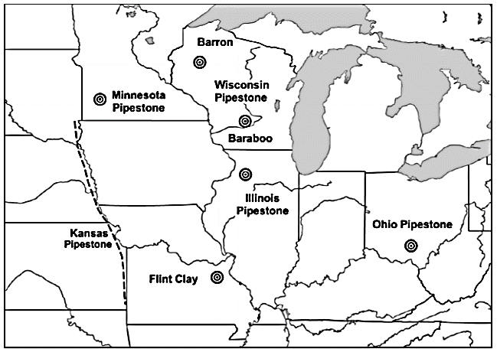

Map showing locations of pipestone sources after Fishel, R.L., Wisseman, S.U., Hughes, R.E. and Emerson, T.E., 2010

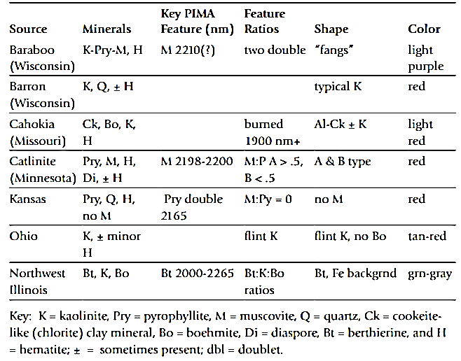

Mineral contents of Midwestern pipestones after Fishel, R.L., Wisseman, S.U., Hughes, R.E. and Emerson, T.E., 2010

*Catlinite Pipe*  
Timothy K. Perttula, Thomas E. Emerson, and Randall E. Hughes  
In: T. Pertulla (ed.) 41HO64/41HO65, Late 17th to Early 18th Century Sites on San Pedro Creek in Houston County, Texas. Bulletin of the Texas Archeological Society 75:96-99, 2004

*Dating Gahagan and Its Implications for Understanding Cahokia-Caddo Interactions*  
Thomas E. Emerson and Jeffrey S. Girard  
Southeastern Archaeology 23 (1), Summer 2004: 57-64, 2004

*The Interpretation and Sourcing of Cahokian Figurines in the Trans-Mississippi South and Southeast*  
Thomas E. Emerson, Randall E. Hughes, Mary Hynes, and Sarah Wisseman  
American Antiquity 68 (2): 287-313, 2003

*Implications of Sourcing Cahokia-style Flint Clay Figures in the American Bottom and the Upper Mississippi River Valley*.   
Thomas E. Emerson, Randall E. Hughes, Mary R. Hynes, and Sarah U. Wisseman  
Midcontinental Journal of Archaeology 27 (2): 309-338, 2002

[*Mineralogical Approaches to Sourcing Pipes and Figurines from the Eastern Woodlands, U.S.A.*](http://www3.interscience.wiley.com/cgi-bin/issuetoc?ID=98518867)  
Sarah U. Wisseman, Duane M. Moore, Randall E. Hughes, Mary R. Hynes, Thomas E. Emerson  
Geoarchaeology 17(7):689-715, 2002

*De-Mything the Cahokia Catlinite Trade*  
Thomas Emerson and Randall Hughes  
Plains Anthropologist 46(175):149-161, May 2001

[*Figurines, flint clay, the Ozark Highlands, and Cahokian acquisition*](http://www.saa.org/publications/AmAntiq/65-1/Emerson.html)  
Emerson, T. E., and R. E. Hughes  
American Antiquity 65(1):79-101, January 2000

[*Revision of Hopewellian trading patterns in midwestern North American based on mineralogical testing*](http://www3.interscience.wiley.com/cgi-bin/issuetoc?ID=77755)  
Hughes, R. E., T. E. Berres, D. M. Moore, and K. B. Farnsworth  
Geoarchaeology 13(7):709-729, 1998

**REPORTS**

*Analysis Report No.1, Midcontinental Archaeometry Working Group, University of Illinois at Urbana-Champaign. August 2003.*  
[PIMA and Hunter Color Analyses on the Westbrook Cahokia Figurine and Bound Warrior Pipe.](http://www2.uiuc.edu/unit/ATAM/mawg/pima/analysisreport1.pdf)  
Hughes, Randall E. and Thomas E. Emerson

*Analysis Report No.2, Midcontinental Archaeometry Working Group, University of Illinois at Urbana-Champaign. August 2003.*  
[Spurlock Paints Second Report.](http://www2.uiuc.edu/unit/ATAM/mawg/pima/analysisreport2.pdf)  
Wisseman, Sarah U. and Randall E. Hughes

**CONFERENCE PRESENTATIONS AND POSTERS**

23rd Annual Meeting of the Wisconsin Archaeological Survey, Madison, April 23, 2005  
*Sourcing Aztalan's Ear Spools*  
John Richards, Randall E. Hughes, and Thomas E. Emerson

Annual Meeting, Friends of Albany Mounds Foundation, Albany, IL, April 19, 2005  
*Albany Mounds State Historic Site, Rock River Pipestone, and the Hopewell Interaction Sphere*  
Thomas E. Emerson

Society of American Archaeology (Salt Lake City, Utah, April, 2005)  
*Turning the World Upside Down: PIMA Sourcing of Scioto Hopewell Temper Mound Pipes*  
Thomas E. Emerson, Randall E. Hughes, Kenneth Farnsworth, and Sarah Wisseman

Conventional wisdom links Hopewell sites in the Scioto Valley with the production and distribution of platform pipes made from the local Feurt Hill pipestone. Our ongoing investigations of Hopewell pipestone sources focuses on the large pipe cache at Tremper Mound using PIMA technology. We have determined that while a small number of pipes were made from Minnesota catlinite, Feurt Hills pipestone, and local sedimentary rocks, the majority were crafted from Sterling pipestone from northern Illinois. Based on this information we propose that the Hopewell Tremper occupants focused on accumulating pipes from diverse locales rather than on their production and distribution.

Archaeological Sciences of the Americas (Tucson, Arizona, September 23-26, 2004)  
*Using a Portable, Non-destructive PIMA SPTM Spectrometer to Source Archaeological Materials and to Detect Restorations in Museum Objects*  
Sarah U. Wisseman, Thomas E. Emerson, Randall E. Hughes, and Mary R. Hynes

A team of archaeologists and geologists demonstrate how a shoebox-size Portable Infrared Mineral Analyzer (PIMA), first used by Australian geologists for mineral exploration, can be applied to provenance and authenticity studies. Good results have been achieved on stone Cahokia "red goddess" figurines and Hopewellian pipes recovered from sites in the Midwestern United States. The data from this totally non-destructive method for determining mineral composition support earlier analyses by X-ray diffraction (XRD) and sequential acid dissolution-inductively coupled plasma (SAD-ICP) and confirm pipestone sources close to the artifact find-spots (Missouri for the figurines and northwestern Illinois for the pipes). The combined results are forcing archaeologists to reevaluate raw material procurement, artifact production, and redistribution for the Middle Mississippian (ca. A.D. 1000-1400) and Middle Woodland (ca. 50 B.C.-A.D. 250) periods. PIMA spectroscopy has also proven useful for characterizing low-fired ceramics containing little or no temper, and distinguishing restoration materials (plaster, shellac, etc.) from original components. The PIMA's advantages (portability, speed, and non-destructiveness) make it a valuable addition to the archaeometrist's arsenal of analytical techniques, most of which are laboratory-based and require some degree of destructive sampling.

Society of American Archaeology (Milwaukee, April 9-13, 2003)  
*Interdisciplinary Approaches to Sourcing Eastern Woodlands Pipes and Figurines*  
Sarah U. Wisseman, Thomas E. Emerson, Mary R. Hynes, and Randall E. Hughes

A team of archaeologists and geologists has used a Portable Infrared Mineral Analyzer (PIMA) to confirm Missouri flint clay as the material used to make Cahokian pipes and figurines. Our current focus is identifying pipestone sources outside of Ohio for Hopewellian pipes and characterizing catlinite used in different periods throughout the Midwest. The shoebox-size PIMA spectrometer is portable, easy to operate, fast (30 seconds per reading), and totally non-destructive. While especially useful in determining the mineral composition of valuable artifacts that cannot be destructively sampled, PIMA spectroscopy is most appropriate as a complement to traditional laboratory techniques such as X-ray diffraction.

48th Annual Meeting of the Midwest Archaeological Conference, Plenary Session "Recent Research on Hopewell Collections, OHS: New Ideas, New Techniques" organized by M. O. Potter--Columbus, OH (October 3-6, 2002)  
*Hopewell Catlinite, Tremper Mound, and PIMA Technology*   
Thomas E. Emerson, Randall E. Hughes, Mary R. Hynes, Kenneth B. Farnsworth, and Sarah U. Wisseman

In the past scholars have macroscopically identified some of the red pipestone pipes utilized by Middle Woodland peoples as Minnesota catlinite. However, few archaeometric studies have been performed to verify these identifications. A recent XRD study on a small number of Wisconsin Hopewell pipes by Boszhardt and Gundersen definitively demonstrated some were made from catlinite. In this paper we report on an expanded study of Ohio (Tremper Mound), Wisconsin, and Illinois pipes using a new non-destructive PIMA technique. This research confirms the limited use of catlinite by Hopewell peoples in the Midwest.

33rd International Symposium on Archaeometry--Amsterdam (April 22-26, 2002)  
*Compositional Analyses Of Archaeological Materials Using A Non-Destructive Portable Spectrometer*  
S. Wisseman (ATAM), T. Emerson (ITARP), M. Hynes (ATAM), R. Hughes (ISGS), D. Moore (ISGS), P. DeMaris (ISGS)

A team at the University of Illinois is employing a shoebox-size PIMA (Portable Infrared Mineral Analyzer) spectrometer in provenance studies of stone Cahokia "red goddess" figurines and Hopewellian pipes recovered from sites in the Midwestern United States. The data from this totally non-destructive method for determining mineral composition support earlier analyses by X-ray diffraction (XRD) and sequential acid dissolution-inductively coupled plasma (SAD-ICP) and confirm pipestone sources close to the artifact find-spots (Missouri for the figurines and northwestern Illinois for the pipes). The combined results are forcing archaeologists to reevaluate raw material procurement, artifact production, and redistribution for the Middle Mississippian (ca. A.D. 1000-1400) and Middle Woodland (ca. 50 B.C.-A.D. 250) periods. PIMA spectroscopy has also proven useful for characterizing low-fired ceramics containing little or no temper, and distinguishing restoration materials (plaster, shellac, etc.) from original components. The PIMA's advantages (portability, speed, and non-destructiveness) make it a valuable addition to the archaeometrist's arsenal of analytical techniques, most of which are laboratory-based and require some degree of destructive sampling.

67th Annual Society for American Archaeology Conference--Denver, CO (March 10-24, 2002)  
*Red Stone Figurines and the Context of Cahokian Acquisition*   
Thomas E. Emerson, Sarah Wisseman, Randall Hughes, and Mary Hynes

Twelfth century Cahokia is depicted as the center of an economic network that stretched across the eastern United States. This supposition is largely untested through archaeometric analyses. Red stone figurines are one of the premier art works involved in this exchange. X-ray diffraction and complementary analyses have demonstrated that the specimens in the Cahokia locality were locally produced from Missouri flint clays. Based on these findings we have continued to investigate the sources of other Southeastern red stone effigies. This expanded investigation, using spectroscopic PIMA technology, indicates most of figurines were crafted at Cahokia itself.

58th Annual Southeastern Archaeological Conference--Chattanooga, TN (November 14-17, 2001)  
*Cahokian Figurines in the Greater Southeast: The Use of PIMA Technology to Source Mississippi Art*  
Thomas E. Emerson, Mary Hynes, Randall Hughes, Sarah Wisseman, and Duane Moore

The Southeast has long been considered the source of many of the large red stone effigy pipes produced by Mississippian peoples. However, X-ray diffraction and complementary analyses by our research group have demonstrated that the specimens in the Cahokia locality were, in fact, locally produced in the 12th century AD from Missouri flint clays. Based on these findings we have continued our research to investigate the sources of stone used to manufacture other Southeastern red stone effigies. This expanded investigation of museum specimens has been possible through the use of a non-destructive spectroscopic PIMA technology. Our initial analysis suggests that many of these red stone effigies were crafted from Missouri flint clays and were likely produced at Cahokia itself.

59th Annual Plains Anthropological Conference, Lincoln, NE (November 1-3, 2001)  
*Sourcing Caddoan and Cahokian Figurines with PIMA Technology*  
Thomas E. Emerson, Mary Hynes, Randall Hughes, Sarah Wisseman

The Caddoan region, especially the area around Spiro, has long been considered the source of many of the large red stone effigy pipes produced in late prehistory. However, X-ray diffraction and complementary analyses by our research group have demonstrated that the specimens in the Cahokia locality were locally produced in the 12th century AD from Missouri flint clays. Based on these findings we have continued our research to investigate the sources of stone used to manufacture Caddoan red stone effigies. This expanded investigation of museum specimens has been possible through the use of a non-destructive spectroscopic PIMA technology. Our initial analysis suggests that many of these Caddoan red stone effigies were crafted from Missouri flint clays and were likely produced at Cahokia itself.

47th Annual Midwest Archaeological Conference--LaCrosse, WI (October 12-14, 2001)  
*PIMA Technology and Cahokia Flint Clay Figures in the Upper Mississippi River Valley*  
Thomas E. Emerson, Mary Hynes, Sarah Wisseman, Randall Hughes

The Southeast has been considered the source of the large red stone effigy pipes produced by Mississippian peoples. X-ray diffraction and complementary analyses by our research group proved that the 12 century AD specimens at Cahokia were produced from Missouri flint clays. Based on these findings we have continued our research to investigate the sources of stone used for Midwestern red stone effigies. This expanded investigation has been performed using a non-destructive spectroscopic PIMA technology. Our analyses indicates a Cahokia source. However, unlike the situation in the Southeast, few large red stone figures seemed to have move out of Cahokia into the UMRV.

66th Annual Society for American Archaeology--New Orleans, LA (April 2001)  
*Application of a PIMA SPª (Portable Infrared Mineral Analyzer) to Pipestone Flint Clay Studies of Two Native American Cultures*  
Mary R. Hynes, Sarah U. Wisseman, Thomas E. Emerson, Randall E. Hughes, Duane M. Moore  
[PDF file of this poster available](http://www2.uiuc.edu/unit/ATAM/mawg/pima/cmspost.pdf)  
  
Geological Society of America--Reno, NV (November 2000)  
*Two New Archaeometric Tools*  
Randall E. Hughes, Sarah U. Wisseman, Mary R. Hynes, Duane M. Moore, and Thomas E. Emerson

X-ray diffraction (XRD) studies of two Native American pipestones showed: 1) that a nearby Missouri flint clay was used for 900-year-old Cahokia figurines, not an Arkansas or Oklahoma source; 2) that a northwestern Illinois flint clay was quarried for 2000-year-old pipestone artifacts of the Havana Hopewell Culture, not a southern Ohio flint clay; and 3) that mineralogical analyses often provide superior source discriminations and are a best first step before chemical analyses.

A sequential acid dissolution-XRD-inductively coupled plasma (XRD/ICP) spectroscopy method verified the cookeite-like chlorite that is unique to the Missouri flint clay and gave us an accurate formula for berthierine in Illinois flint clay. These analyses detected lithium that fills previously reported octahedral vacancies in the berthierine structure. The method can be used for most geological materials.

The PIMA (portable infrared mineral analyzer) increases analysis speed (and decreases cost) to about one/min., and provides completely portable and nondestructive mineral analyses. Initial PIMA insights include: 1) validation of the Missouri source for Cahokia artifacts; 2) identification of burned and unburned fragments within reassembled Cahokia figurines and debris collections; and 3) corrected sources for catlinite-like artifacts. Because the PIMA sees mineral-structural features that are hidden from XRD, a lab-mounted PIMA is a near-perfect research complement to XRD. The PIMA also is being used to analyze sediment cores, identify and select representative samples from large collections, analyze thin section collections, characterize ceramic source clays, and measure the degree of ceremonial burning or firing of artifacts.

Clay Minerals Society--Chicago, IL (June 2000)  
*Application of a PIMA SPª (Portable Infrared Mineral Analyzer) to Pipestone Flint Clay Studies of Two Native American Cultures*  
Mary R. Hynes, Sarah U. Wisseman, Thomas E. Emerson, Randall E. Hughes, Duane M. Moore  
[PDF file of this poster available](http://www2.uiuc.edu/unit/ATAM/mawg/pima/cmspost.pdf)  
  
30th International Symposium on Archaeometry--Urbana, IL (1996)  
[*Sourcing the Cahokia-Style Figurines*](http://www.anthro.uiuc.edu/itarp/exhibits/#sourcing)  
Randall E. Hughes and Thomas E. Emerson  
  
Annual Meeting of American Association for the Advancement of Science--Chicago, IL (1992)  
*New Illinois Pipestone Revises Hopewell Trade Routes*  
Randall E. Hughes, Duane M. Moore, Kenneth B. Farnsworth, and Thomas E. Berres  
  
54th Annual Plains Anthropological Conference-- Iowa City, IA (1996)  
*Flint clay, Figurines, and the Cahokia Trade in Elite Goods*  
Thomas E. Emerson, and Randall E. Hughes  
  
54th Annual Plains Anthropological Conference-- Iowa City, IA (1996)  
*Minerals distinguish Native American pipestone sources*  
Randall E. Hughes, Duane M. Moore, Thomas E. Berres, Thomas E. Emerson, and Kenneth B. Farnsworth  
  
27th Annual Meeting of the Clay Minerals Society, Columbia, MO (1990)  
*Berthierine pipestones of Native Americans in the Mid-continent*  
Randall E. Hughes, Duane M. Moore, Thomas E. Berres, and Kenneth B. Farnsworth

**OTHER PRESENTATIONS**

Understanding Our Earth Scientific Seminar, November 12, 2003  
Randall Hughes, Emeritus Sr. Geologist, ISGS  
*Better, Faster, Cheaper, and Friendlier Mineralogy: Status and Future Potential of Our 70+-Year-Old Program*  
  
Indiana Geological Survey seminar, February 6, 2003  
Randall Hughes, Senior Research Scientist, ISGS  
*Better, Faster, Cheaper Mineralogy with the PIMA-SPTM (Portable Infrared Mineral Analyzer)*  
  
ISGS Seminar, Jan 29, 2003  
Thomas Emerson, Director, ITARP  
*Prehistoric Art and Geological Sciences: Inseparable Companions*  
  
Anthropology 398 class, April 5 2002  
Sarah Wisseman, Director, ATAM  
*PIMA SP Spectroscopy for Archaeologists*  
  
Beckman Institute seminar, UIUC, Feb. 19, 2002  
Sarah Wisseman, Director, ATAM  
*Science in the Art Museum*  
  
Materials Research Laboratory seminar, May 22, 2001  
Sarah Wisseman, Director, ATAM  
*Science and Archaeology: Interdisciplinary Research by the ATAM Program*  
  
East Central Illinois Archaeological Society, March 14, 2001  
Randall E. Hughes, Senior Research Scientist, ISGS  
*What the Silent Stones say to a Geologist: Applying Mineralogical and Related Geochemical Methods to Archaeology*  
  
Imaging Technology Group, University of Illinois, November 2, 2000  
Sarah Wisseman, Director, ATAM  
*Images of the Past: Recent Research by the Program on Ancient Technologies and Archaeological Materials*  
  
ATAM seminar, Oct. 25, 1999  
Randall E. Hughes, Senior Research Scientist, ISGS  
*The New PIMA ((Portable Infrared Mineral Analyzer: A New Aid in the Mineralogical "Sourcing" of Stone and Ceramic Artifacts*  
  
ISGS Seminar, Sept. 22, 1998  
Randall E. Hughes, Senior Research Scientist, ISGS  
*The New PIMA (Portable Near-Infrared Mineral Analyzer) for Aggregate, Archaeology, Clay Mineral, Fuel, Geochemistry, Mapping, and other ISGS Programs*